Contents

1 🔧What’s New 2

2 🚀 Fixed Defects 2

3 🚀 Fixed Issues 2

4 ⭐ Improvements 2

5 🚀 Deployments 3

5.1 Infrastructure 3

5.1.1 App Registrations 3

5.1.2 Pre-Deployment Steps: 3

5.1.3 Deployment 3

5.2 CRM 4

5.2.1 Import TASMU_CPM_Core solution 4

5.2.2 Deployment 4

5.2.3 CRM Post Deployment Verification 4

5.2.4 CRM Email Template Links Update 4

5.3 CDN 5

5.4 Web Apps 5

5.5 Platform APIs 5

5.6 BOT 5

5.7 APIM 5

5.8 Mobile 5

5.9 B2C Tenant Policy Files 5

6 💻 Reviewers 6

7 Appendix 7

7.1 Post Deployment Verification 7

7.2 Running Pipeline from Tags 7

Release Notes

# 🔧What’s New

New user stories delivered: **None**

# 🚀 Fixed Defects

The following bugs reported in SIT are addressed in the current interim build –

| **ID** | **Title** | **Severity** | **Priority** |
| --- | --- | --- | --- |
| [36108](https://dev.azure.com/TASMUCP/TASMU%20MSI/_workitems/edit/36108) | FN-B2B Marketplace-Google map is not available on Contact Us page | 3 - Medium | 2 |
| [36262](https://dev.azure.com/TASMUCP/TASMU%20MSI/_workitems/edit/36262) | FN - B2B Portal - Social accounts should forward to TASMU social account | 3 - Medium | 1 |
| [36441](https://dev.azure.com/TASMUCP/TASMU%20MSI/_workitems/edit/36441) | NF-Notification-Email verification mail while registering account is not as per template | 3 - Medium | 1 |
| [36571](https://dev.azure.com/TASMUCP/TASMU%20MSI/_workitems/edit/36571) | FN - B2B - No message shown when user does not select Terms & Cond., Privacy Policy checkbox while ordering a product, also some error is shown | 3 - Medium | 1 |
| [36573](https://dev.azure.com/TASMUCP/TASMU%20MSI/_workitems/edit/36573) | FN - B2B - User is unable to see the reviews | 3 - Medium | 2 |
| [36580](https://dev.azure.com/TASMUCP/TASMU%20MSI/_workitems/edit/36580) | NF-Localization-Product configuration fields- "Is required" message, Continue to subscribe button is not in Arabic | 3 - Medium | 1 |

# 🚀 Fixed Issues

The following issues reported are addressed in the current build –

| **ID** | **Type** | **Title** | **Priority** |
| --- | --- | --- | --- |
| [36471](https://dev.azure.com/TASMUCP/TASMU%20MSI/_workitems/edit/36471) | Issue | Image cropping | 2 |

# ⭐ Improvements

* Profile API performance enhancements.

# 🚀 Deployments

## Infrastructure

Pull Request – [Pull request 7282: Merge TASMU CP into TASMU MSI - 03 June 2021 - Repos (azure.com)](https://dev.azure.com/TASMUCP/TASMU%20MSI/_git/infra/pullrequest/7282)

### App Registrations

1. App registration name: **spn-crm-profile-daemon-integration-<env>** in Azure AD (not in B2C) for pre and prd. (Already done by Fahim)
2. Generate a Client Secret
3. Keep the Client Id and Client Secret for seeding in app configuration and key vault.

### Pre-Deployment Steps:

1. Add the below two [key vault secrets](https://dev.azure.com/TASMUCP/TASMU%20Central%20Platform/_wiki/wikis/TASMU-Central-Platform.wiki/151/Key-Vault-Secrets-Apps) to kv-<sub>-apps-<env>-we-01, refer wiki link on retrieval details:

* Crm-ProfileDaemon-DynamicsSettings-ClientSecret
* CkanSettings-CkanStroageAccountConnectionString

1. Once this change is completed, the ckan container of storage account dlsopenzone<env>we01 should have public access level as *‘private*’.  
   For reference:  
   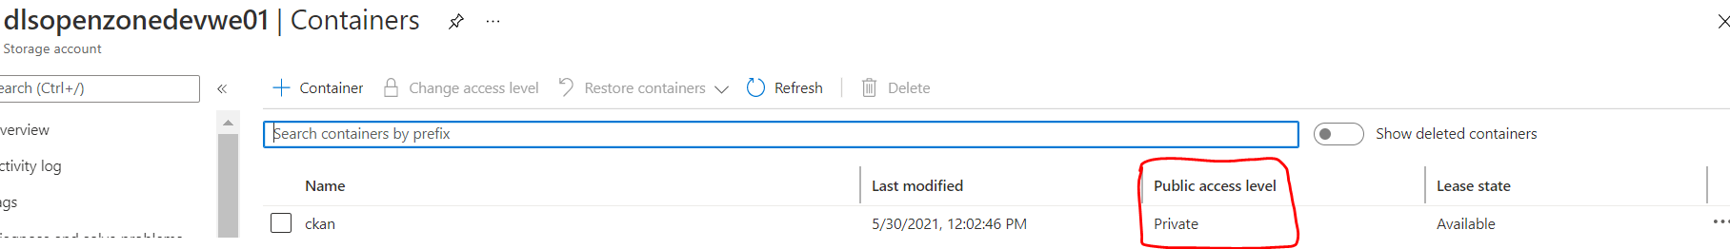  
   If it is not private, check the checkbox on container ckan and click on change access level. then select private.  
   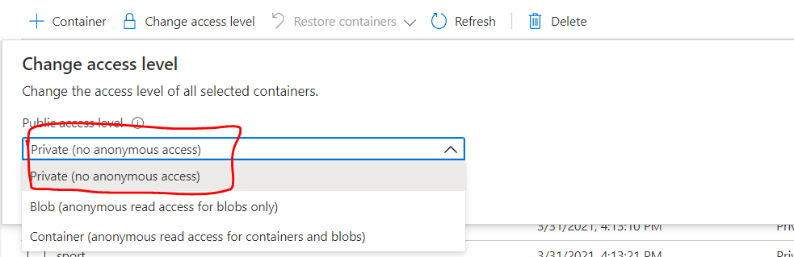
2. Update the app configurations file for below keys:

* Refer PR - [7271](https://dev.azure.com/TASMUCP/TASMU%20Central%20Platform/_git/infra/pullrequest/7271) to add Client Id configurations of **spn-crm-profile-daemon-integration-<env>**
  + Update files
    - Scripts\AppConfigurations\keyvaultref\<env>\appsettings.json
    - Scripts\AppConfigurations\settings\<env>\appsettings.json
* Add CkanSettings:CkanStroageAccountConnectionString to key vault ref app configuration
  + Update file
    - Scripts\AppConfigurations\keyvaultref\<env>\appsettings.json

### Deployment

1. CD-**AppConfigurations**-Master-Release

## CRM

### Import TASMU_CPM_Core solution

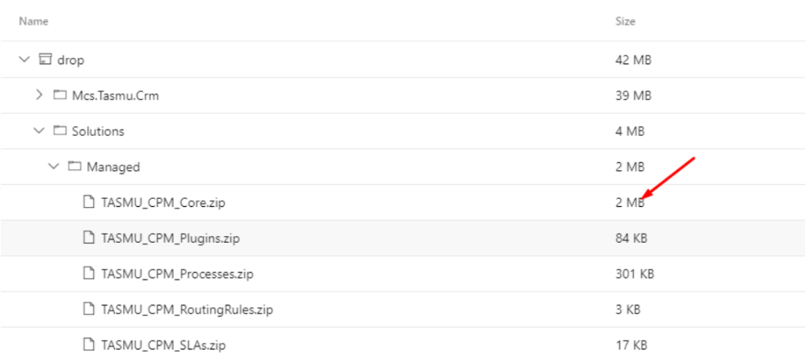

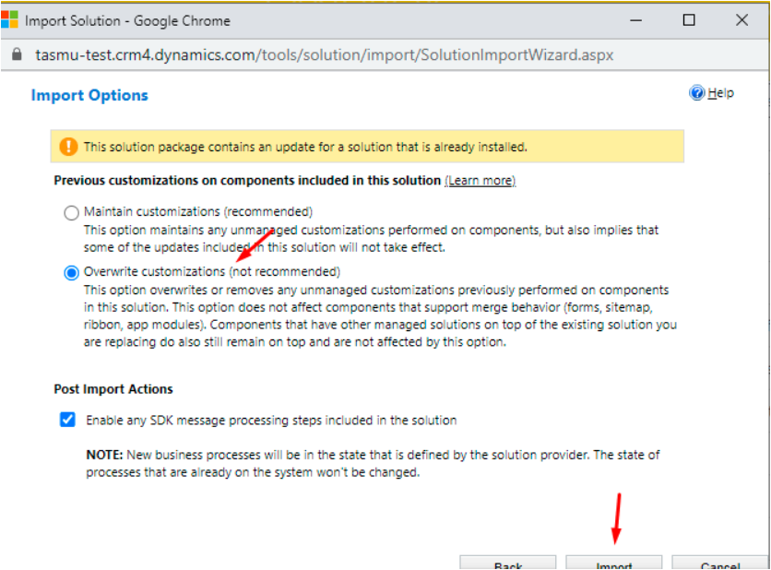

### Deployment

|  |  |
| --- | --- |
| **Build Id** | **Pipeline Name** |
| 44954 | [CD-CrmPlatform-Release](https://dev.azure.com/TASMUCP/TASMU%20Central%20Platform/_build/results?buildId=44954&view=results) |

### CRM Post Deployment Verification

[Verify workflows and business rules are activated from deployment guide](https://dev.azure.com/TASMUCP/TASMU%20Central%20Platform/_wiki/wikis/TASMU-Central-Platform.wiki/137/Dynamics-365-Deployment-Guide) (Refer 5.16 section)

### CRM Email Template Links Update

[Link to be changed in email templates in CRM and Images needs to be uploaded for Prod](https://dev.azure.com/TASMUCP/TASMU%20Central%20Platform/_wiki/wikis/TASMU-Central-Platform.wiki/137/Dynamics-365-Deployment-Guide?anchor=5.17-email-templates-in-crm-and-images-needs-to-be-uploaded-for-prod) (Refer 5.17 section)

## CDN

|  |  |
| --- | --- |
| **Tag** | **Pipeline Name** |
| SIT_CDN_03June2021 | [CD-CDNContainer-Release](https://dev.azure.com/TASMUCP/TASMU%20Central%20Platform/_build/results?buildId=44979&view=results) |

## Web Apps

|  |  |
| --- | --- |
| **Tag** | **Pipeline Name** |
| SIT_Web_03June2021 | [CD-WebApps-Prd-Release](https://dev.azure.com/TASMUCP/TASMU%20Central%20Platform/_build?definitionId=1020) |

## Platform APIs

|  |  |
| --- | --- |
| **Tag** | **Pipeline Name** |
| SIT_API_03June2021 | [CD-PlatformAPIs-Prd-Release](https://dev.azure.com/TASMUCP/TASMU%20Central%20Platform/_build?definitionId=1021) |

## BOT

|  |  |
| --- | --- |
| **Tag** | **Pipeline Name** |
| SIT_Bot_03June2021 | [CD-BotApi-Prd-Release](https://dev.azure.com/TASMUCP/TASMU%20Central%20Platform/_build?definitionId=1022) |

## APIM

|  |  |  |
| --- | --- | --- |
| **Tag** | **APIs** | **Pipeline Name** |
| SIT_APIM_03June2021 | cmsdocumentsapi | [CI-APIMConfig-CentralPlatformCore-Master-Prd-Build](https://dev.azure.com/TASMUCP/TASMU%20Central%20Platform/_build?definitionId=1150) |
| SIT_APIM_03June2021 | cmsdocumentsapi | [CD-APIMConfig-pre-Release](https://dev.azure.com/TASMUCP/TASMU%20Central%20Platform/_build?definitionId=962) |

## Mobile

|  |  |  |
| --- | --- | --- |
| **Platform** | **Build Id** | **Pipeline Link** |
| Android | 44888 | <https://dev.azure.com/TASMUCP/TASMU%20Central%20Platform/_build/results?buildId=44888&view=results> |
| iOS | 44889 | <https://dev.azure.com/TASMUCP/TASMU%20Central%20Platform/_build/results?buildId=44889&view=results> |

## B2C Tenant Policy Files

1. Upload new policy files. Source – Tag – [SIT_Web_03June2021](https://dev.azure.com/TASMUCP/TASMU%20Central%20Platform/_git/web-apps?version=GTSIT_Web_03June2021)
   1. B2C_1A_B2B_TrustFrameworkBase_<env>
   2. B2C_1A_BO_TrustFrameworkBase_<env>
   3. B2C_1A_TrustFrameworkBase_<env>
2. Please apply any B2C policy customizations selectively done for pre prod environment.

# 💻 Reviewers

|  |  |
| --- | --- |
| Prepared By | Manvir Kaur, Sumit Gupta |
| Company name | Microsoft |
| Reviewed by | Ravi Sankar Pillutla, Anil Erkek, Subhajit Chatterjee, Gareeb Navas T M, Mecit Atmaca |
| Approved by | Ashwani Sharma |

# Appendix

## Post Deployment Verification

1. Function Apps Running
2. <https://func-cpp-apps-ckan-pre-we-01.azurewebsites.net/>
3. <https://func-cpp-apps-qnasync-pre-we-01.azurewebsites.net/>
4. <https://func-cpp-apps-luistra-pre-we-01.azurewebsites.net/>
5. <https://func-cpp-apps-intbpa-pre-we-01.azurewebsites.net/>
6. <https://func-cpp-apps-intntf-pre-we-01.azurewebsites.net/>
7. <https://func-cpp-apps-pt-pre-we-01.azurewebsites.net/>
8. Marketplace Portal - <https://marketplace.pre.sqcp.qa/en/>
9. Bot – Chat with bot on marketplace
10. My Tasmu Portal - <https://mytasmu.pre.sqcp.qa/en/>
11. Account Portal - <https://account.pre.sqcp.qa/en/>
12. Admin Portal Portal - [https://cpadmin.pre.sqcp.qa](https://cpadmin.pre.sqcp.qa/)  (Login screen should come)
13. API Config access - <https://api.pre.sqcp.qa/config/api/feature>
14. Open Data Portal - <https://opendata.pre.sqcp.qa/>

## Running Pipeline from Tags

